**Task-1**

Create a custom numpy ufunc (universal function) and apply it to a numpy array.

1. **Task** **Description:**

* To create a custom ufunc (universal function) in NumPy, you can use the frompyfunc function, which allows to create a NumPy ufunc from a Python function.

**2. Task Output Screenshot**

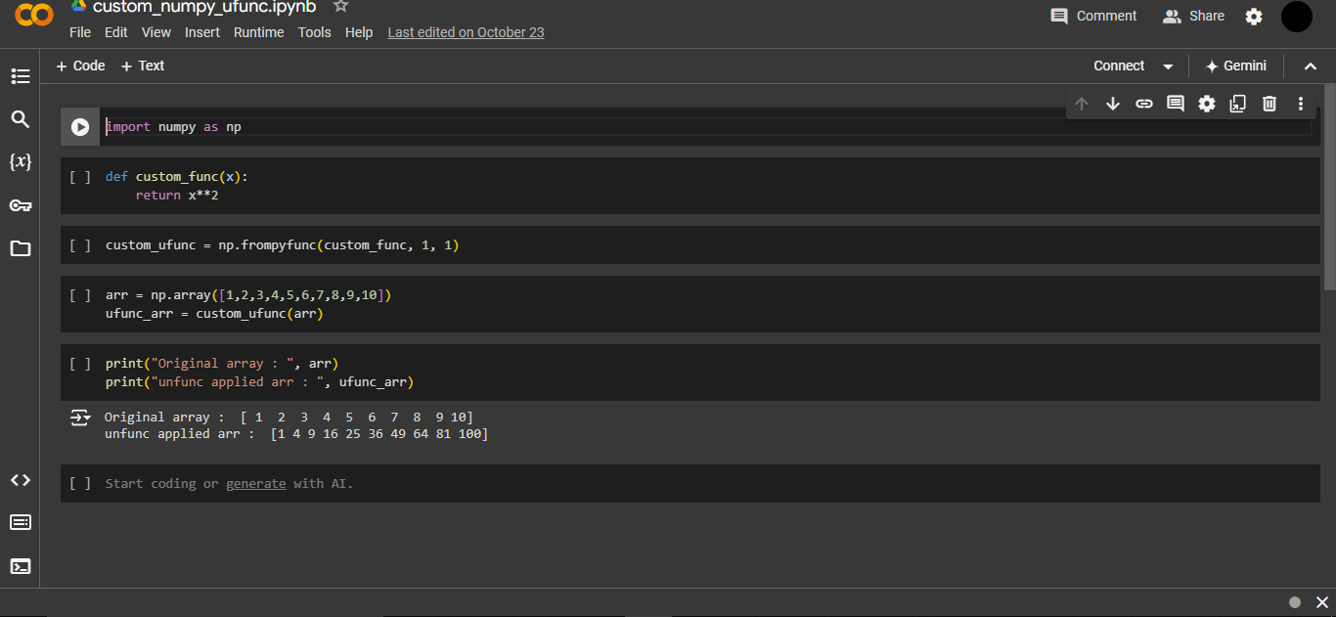

1. **Algorithm Used In Task**

* np.frompyfunc(func, nin, nout):
* func: The Python function to convert.
* nin: Number of input arguments to the function (in this case, 1).
* nout: Number of output arguments from the function (in this case, 1).
* custom_ufunc to a NumPy array and it processes each element individually.